**1.Download jenkins war from jenkins website**

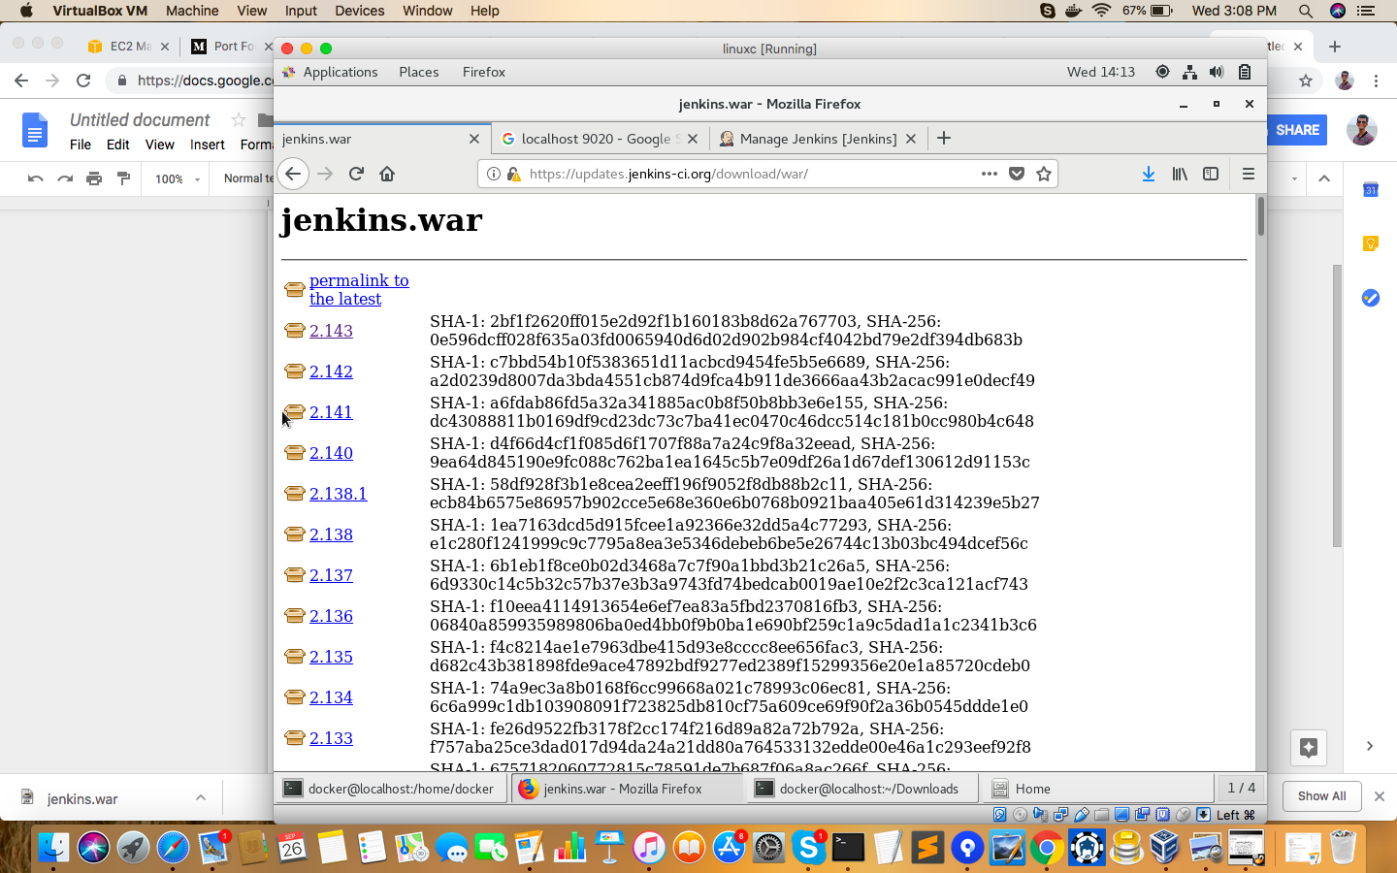

**2.Run the The following command:**

Navigate to the directory where the war file is located

java -jar jenkins.war --httpPort=9020&

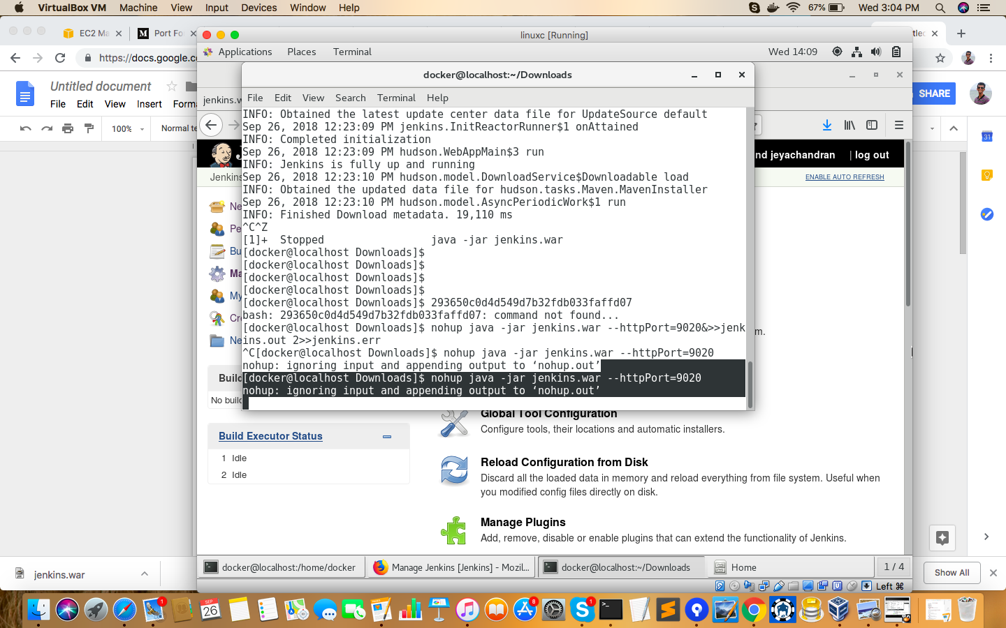

3.Navigate to manage jenkins and click on configure global security

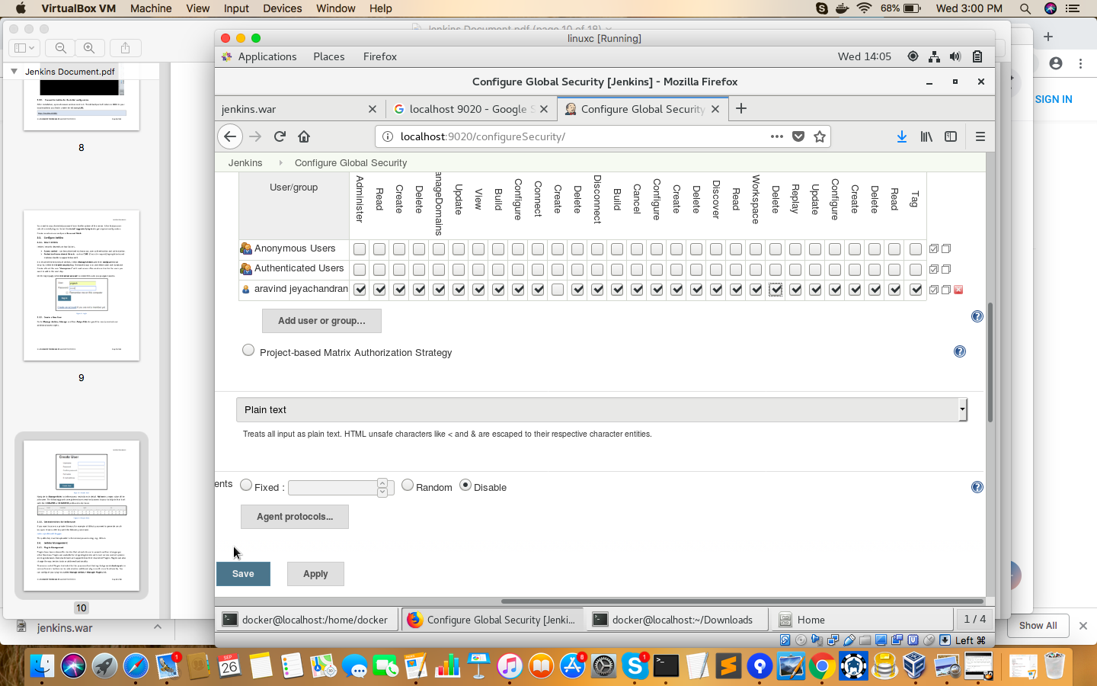

4.

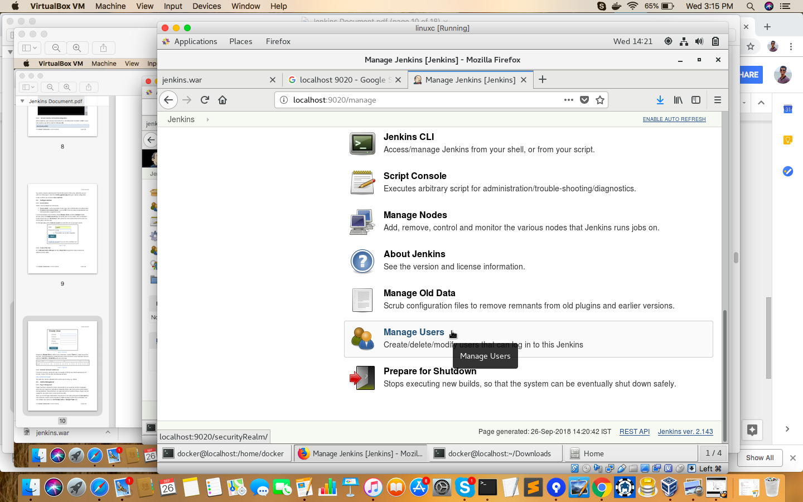

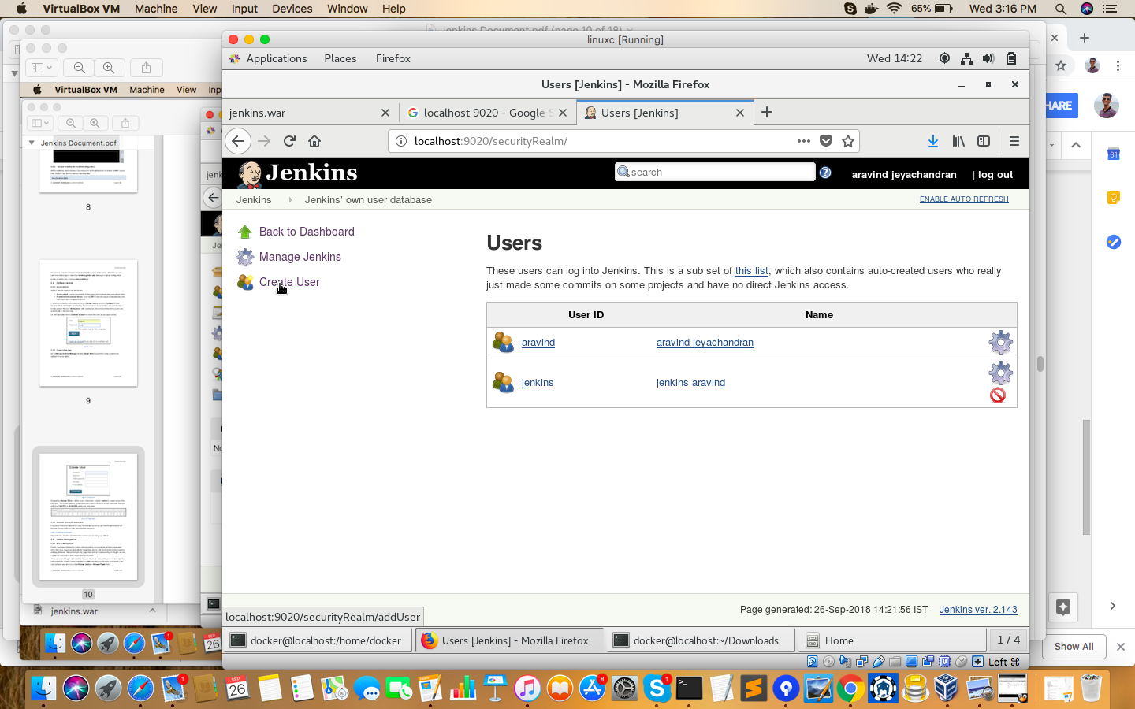

Creating user

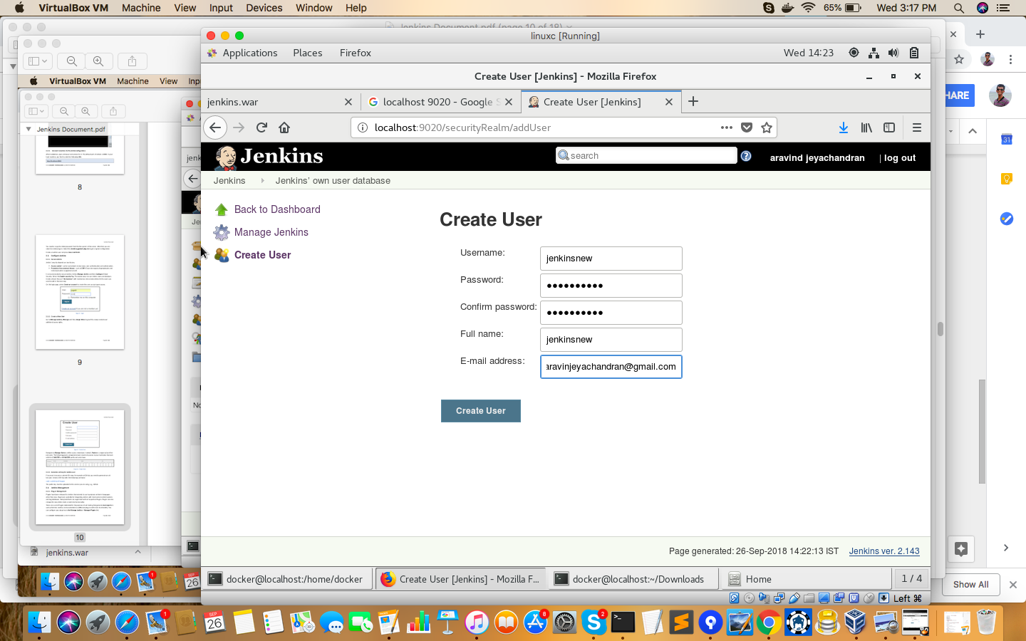

Typing the username password for a new user.

Creating a new job:

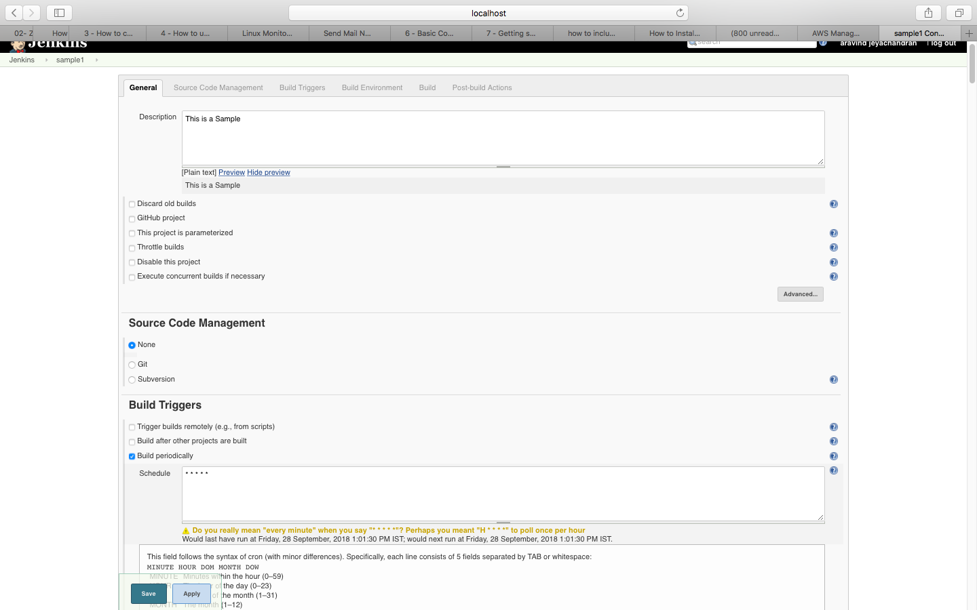

The job is created and built.

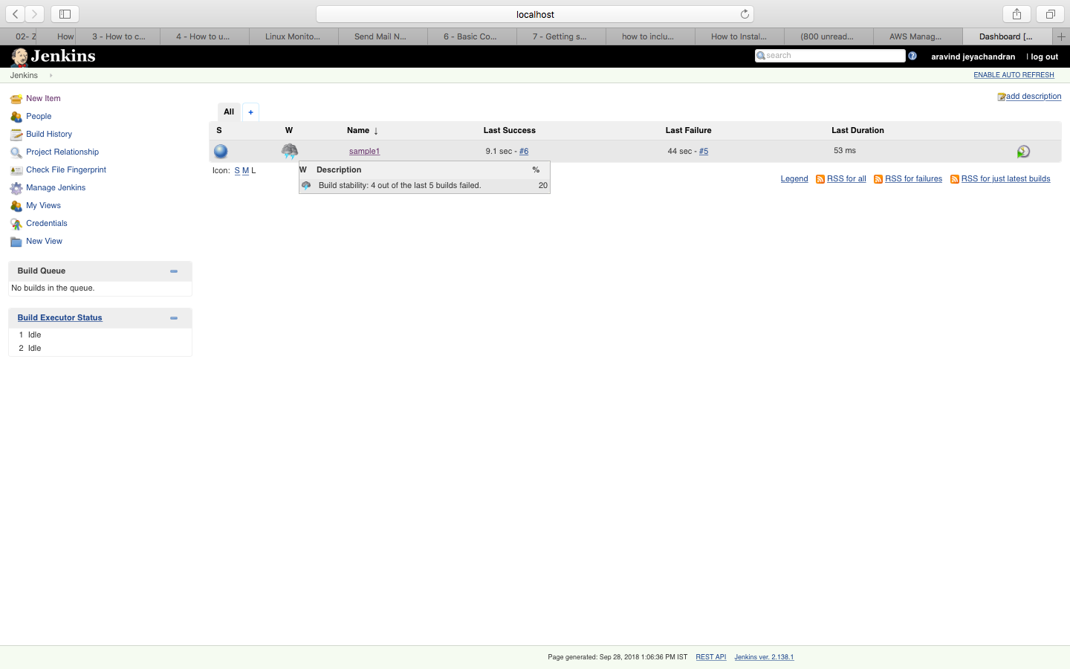

**Terminal actions:**

Terminal is recording all the actions done in jenkins including builds failed and builds that succeeded.

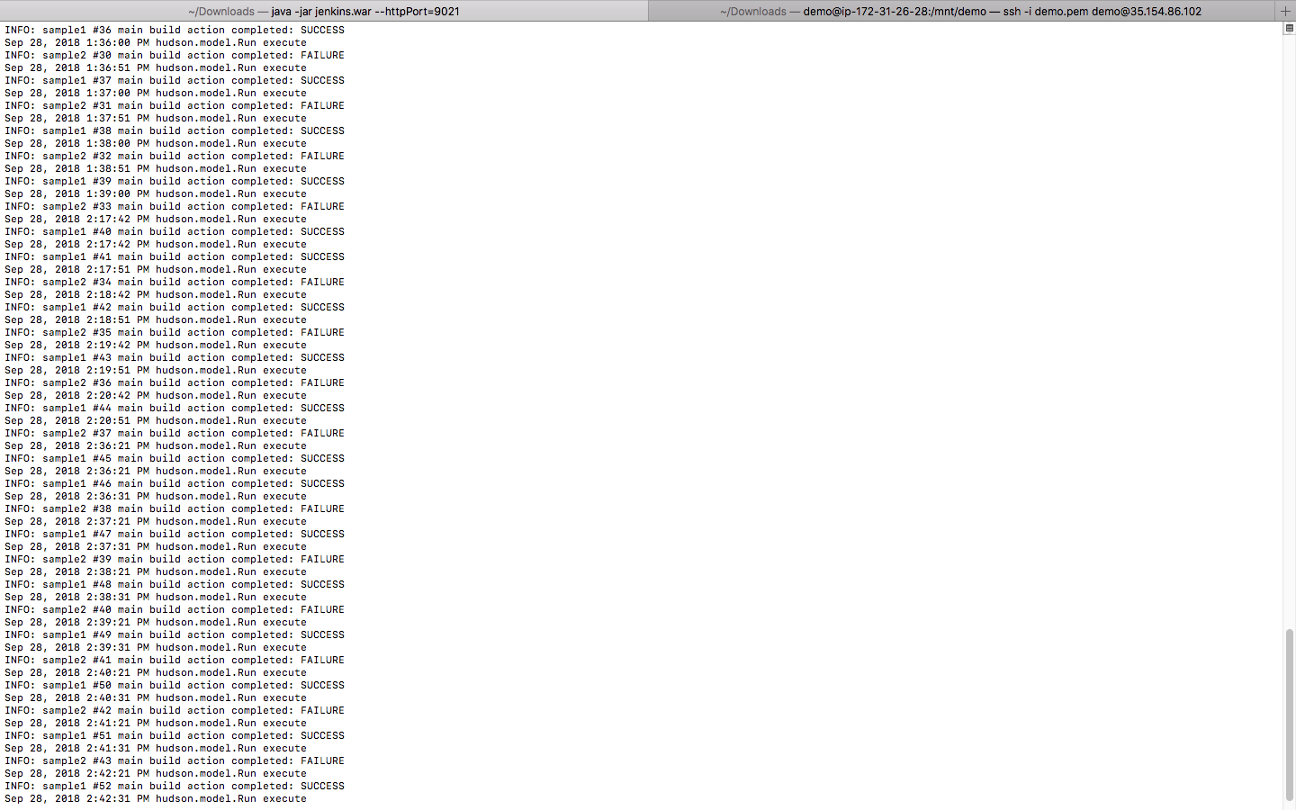

**Creating trigger:**

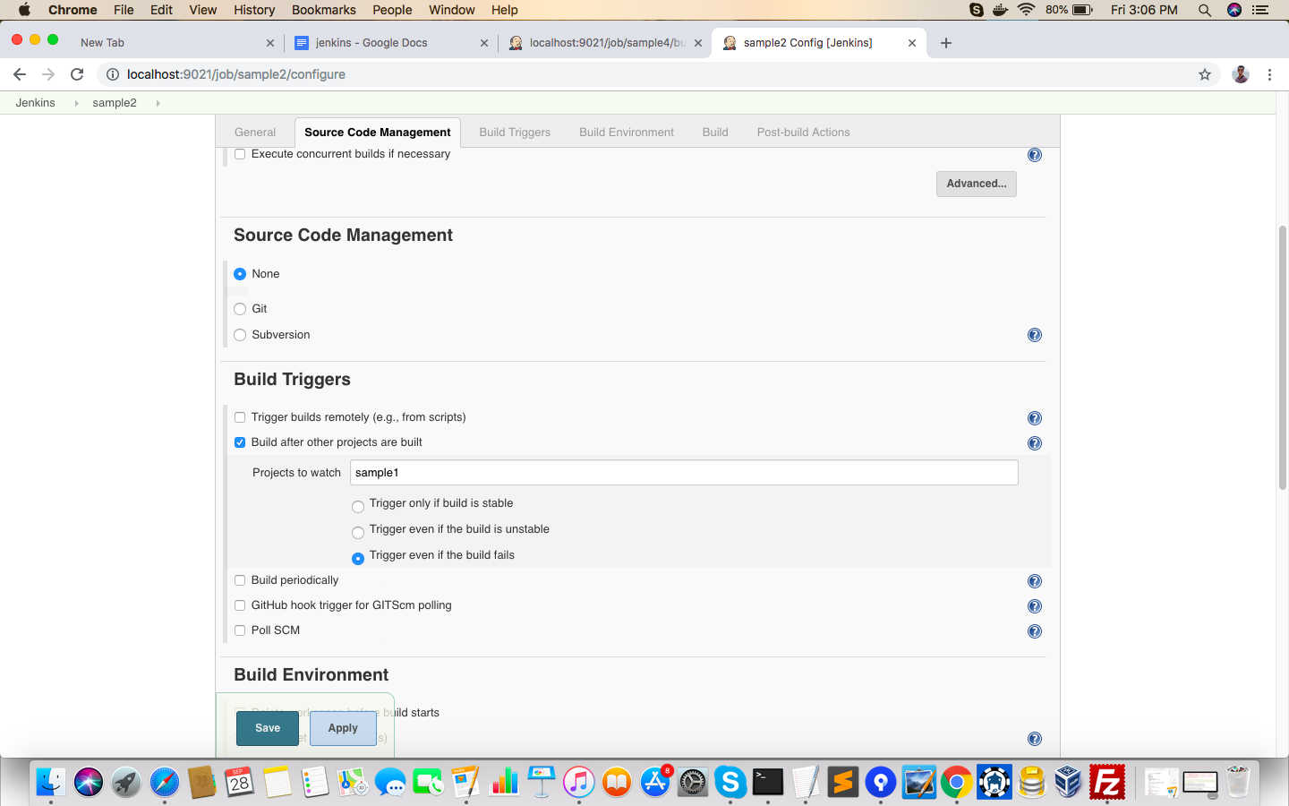

**Sample 2 is built after sample one is built.**

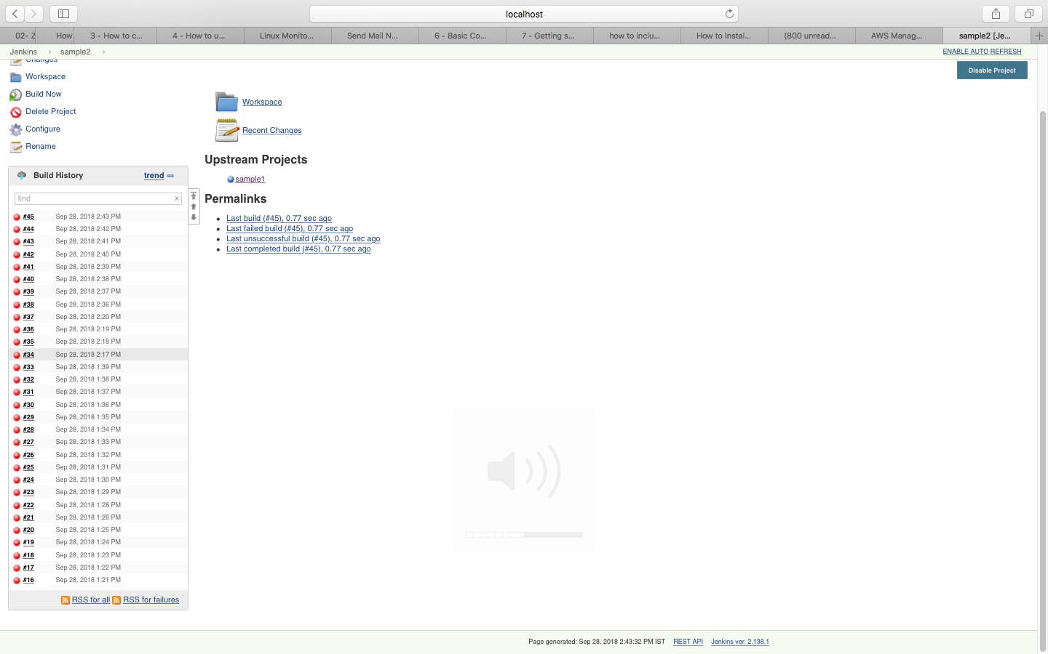

**Sample 4 is configured:**

**It is configured with authentication token making us build it remotely**

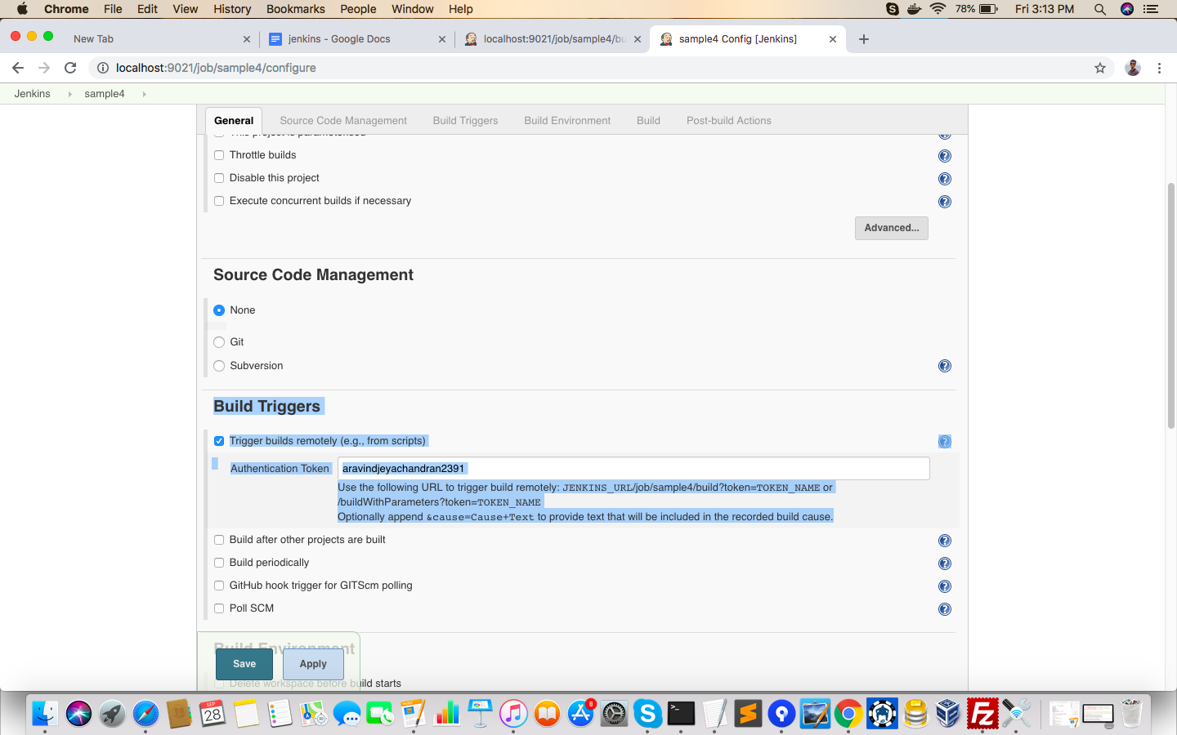

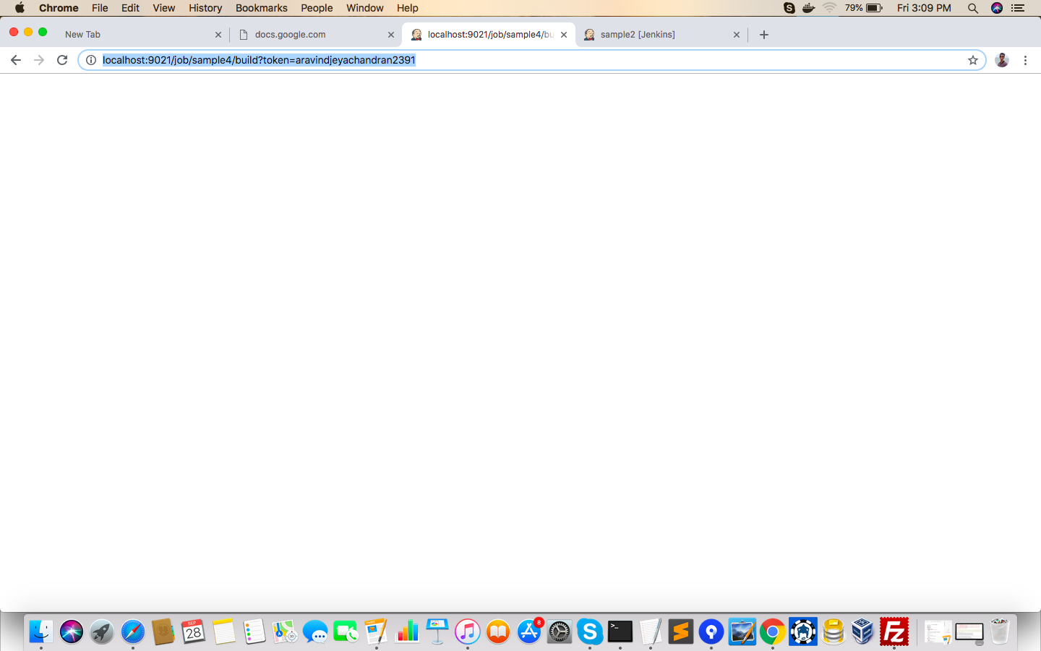

**The job can be accessed remotely.**

**There is a build that has been built in sample 4:**

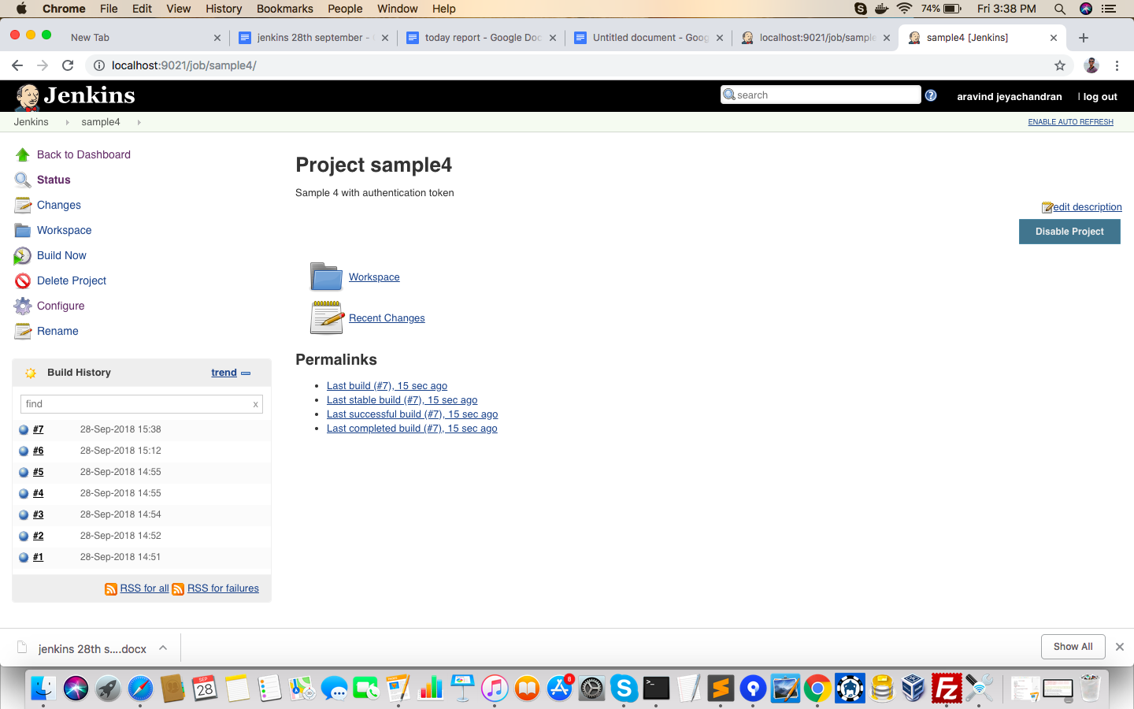

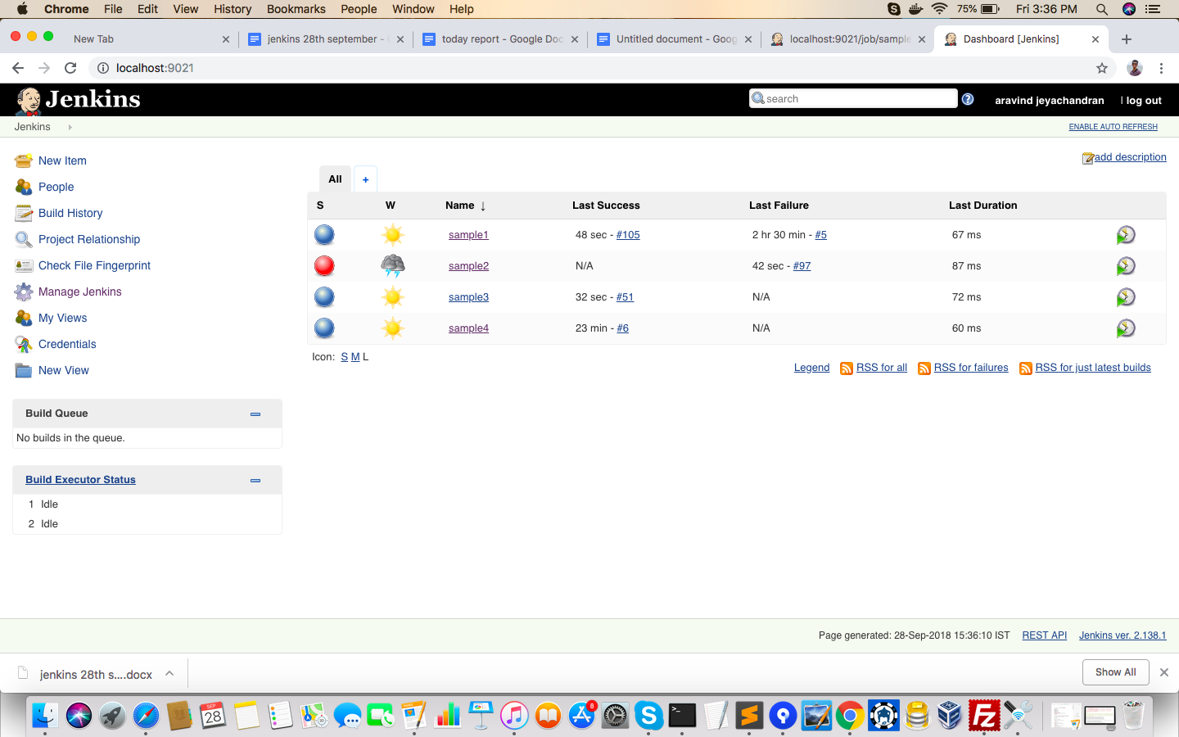

**The jobs are shown in the dashboard..**